Отчёт по тестированию алгоритмов

№1

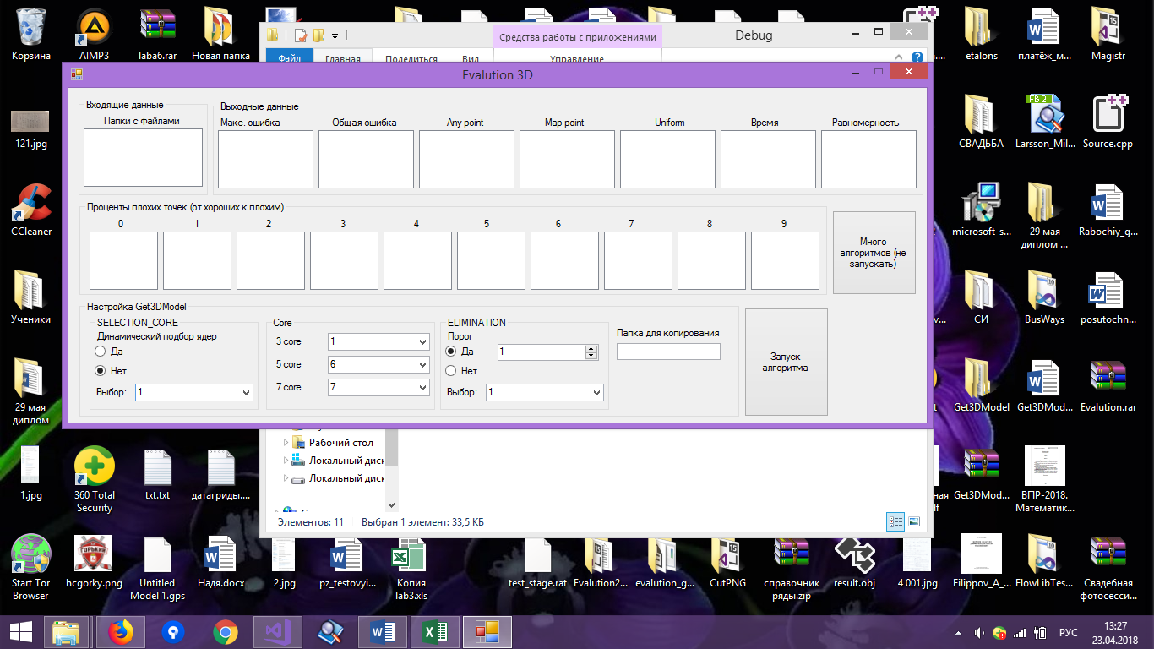

|  |  |  |  |  |  |  |  |  |  |
| --- | --- | --- | --- | --- | --- | --- | --- | --- | --- |
|  | max_err | total_err | map point | any point | равномерность  % | заполняемость  % | t | t норм. | Uniform  % |
| test_3x3 | 8 | 21139,46 | 640000 | 26337 | 100 | 4,1% | 908 | 0,00014 | 98,44 |
| test_conus | 3 | 1322,50 | 640000 | 18960 | 100 | 2,9% | 610 | 0,000095 | 95,47 |
| test_QS | 27,5 | 46589,95 | 640000 | 8500 | 83,33 | 1,32% | 897 | 0,000063 | 89,51 |
| test_torus | 14,38 | 13809,93 | 640000 | 15344 | 83,33 | 2,4% | 21 | 0,0000014 | 91,67 |
| ∑ | 13,22 | 20715,46 |  | 17285,25 | 91,665 | 2,68% |  | 0,0000748 | 93,77 |

Процент плохих точек по областям по отношению ко всем точкам (от «хороших» к «плохим»)

|  |  |  |  |  |  |  |  |  |  |  |
| --- | --- | --- | --- | --- | --- | --- | --- | --- | --- | --- |
|  | 1 | 2 | 3 | 4 | 5 | 6 | 7 | 8 | 9 | 10 |
| test_3x3 | 2,42% | 0,09% | 1,59% | 0,00% | 0,00% | 0% | 0,00% | 0,00% | 0,00% | 0,00% |
| test_conus | 2,86% | 0,01% | 0% | 0,07% | 0% | 0% | 0,00% | 0% | 0% | 0,00% |
| test_QS | 0,54% | 0,23% | 0,24% | 0,16% | 0,03% | 0,01% | 0,01% | 0,02% | 0,02% | 0,02% |
| test_torus | 2,07% | 0,02% | 0,05% | 0,11% | 0,03% | 0,02% | 0,01% | 0,01% | 0,01% | 0,01% |

№2 ( Хорошие результаты)

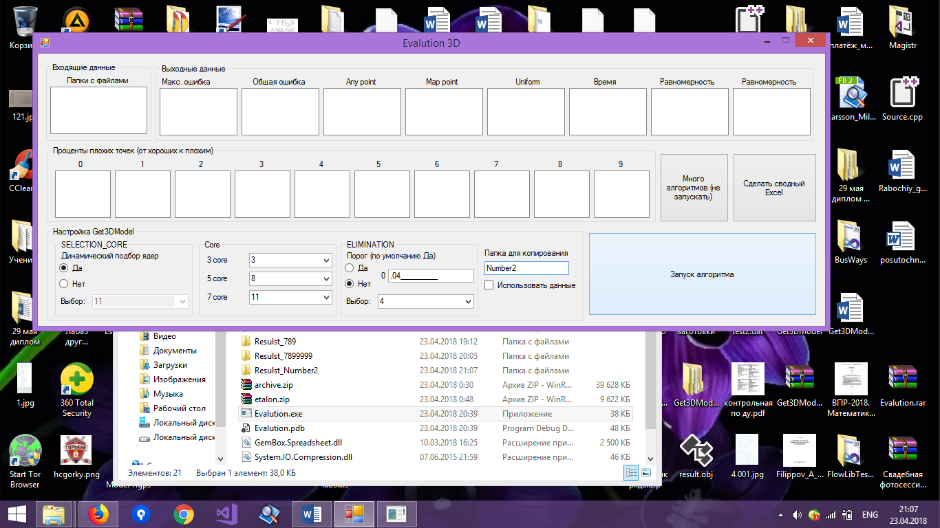

|  |  |  |  |  |  |  |  |  |  |
| --- | --- | --- | --- | --- | --- | --- | --- | --- | --- |
|  | max_err | total_err | map point | any point | равномерность  % | заполняемость  % | t | t норм. | Uniform  % |
| test_3x3 | 9 | 861889,43 | 640000 | 540489 | 100 | 84 | 137778 | 0,022 | 100 |
| test_conus | 9,00 | 478425,90 | 640000 | 530954 | 100 | 82 | 136543 | 0,021 | 100 |
| test_QS | 27,5 | 3700682,22 | 640000 | 549175 | 100 | 85 | 319071 | 0,023 | 100 |
| test_torus | 21 | 2351537,74 | 640000 | 568388 | 100 | 88 | 340242 | 0,024 | 100 |
| ∑ | 16,625 | 1848133,8 |  | 547251,5 | 100 | 84,75 |  | 0,0225 | 100 |

Процент плохих точек по областям по отношению ко всем точкам (от «хороших» к «плохим»)

|  |  |  |  |  |  |  |  |  |  |  |
| --- | --- | --- | --- | --- | --- | --- | --- | --- | --- | --- |
|  | 1 | 2 | 3 | 4 | 5 | 6 | 7 | 8 | 9 | 10 |
| test_3x3 | 38,54% | 4,91% | 28,82% | 2,25% | 1,74% | 1,75% | 1,75% | 1,74% | 1,58% | 1,32% |
| test_conus | 69,13% | 2,80% | 1,48% | 1,4% | 1,45% | 1,44% | 1,42% | 1,39% | 1,25% | 1,17% |
| test_QS | 20,70% | 18,12% | 15,85% | 17,95% | 5,46% | 3,67% | 3,20% | 0,76% | 0,02% | 0,02% |
| test_torus | 48,44% | 6,72% | 9,55% | 5,90% | 4,88% | 4,36% | 3,51% | 1,80% | 1,49% | 2,12% |

№3

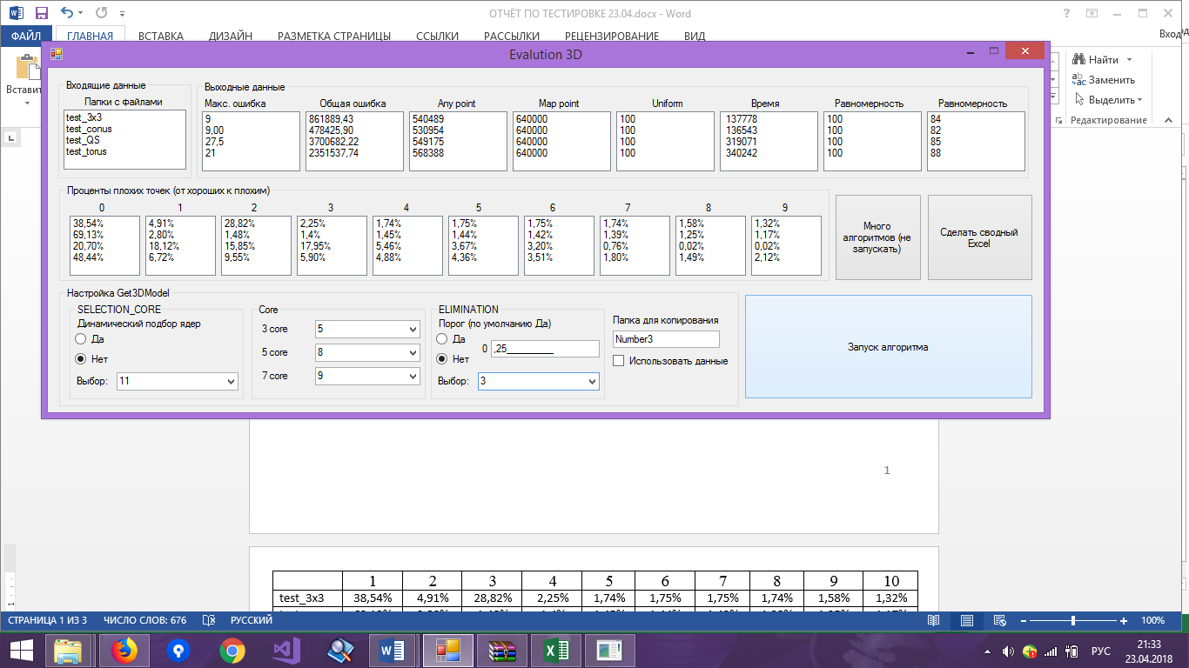

|  |  |  |  |  |  |  |  |  |  |
| --- | --- | --- | --- | --- | --- | --- | --- | --- | --- |
|  | max_err | total_err | map point | any point | равномерность  % | заполняемость  % | t | t норм. | Uniform  % |
| test_3x3 | 8 | 14871,24 | 640000 | 19627 | 100 | 3,06% | 96695 | 0,015 | 97,72 |
| test_conus | 3 | 970,22 | 640000 | 13478 | 100 | 2,1% | 93579 | 0,0146 | 93,87 |
| test_QS | 27,5 | 36509,06 | 640000 | 6415 | 83,33 | 1% | 210477 | 0,0149 | 85,01 |
| test_torus | 14,38 | 8598,05 | 640000 | 11326 | 83,33 | 1,76% | 188754 | 0,0134 | 88,76 |
| ∑ | 13,22 | 15237,142 |  | 12711,5 | 91,665 | 1,98 |  | 0,0144 | 91,34 |

Процент плохих точек по областям по отношению ко всем точкам (от «хороших» к «плохим»)

|  |  |  |  |  |  |  |  |  |  |  |
| --- | --- | --- | --- | --- | --- | --- | --- | --- | --- | --- |
|  | 1 | 2 | 3 | 4 | 5 | 6 | 7 | 8 | 9 | 10 |
| test_3x3 | 1,86% | 0,09% | 1,10% | 0,00% | 0,00% | 0% | 0,00% | 0,00% | 0% | 0,00% |
| test_conus | 2,02% | 0,00% | 0% | 0,07% | 0% | 0% | 0,00% | 0% | 0% | 0,00% |
| test_QS | 0,43% | 0,15% | 0,17% | 0,11% | 0,02% | 0,01% | 0,01% | 0,02% | 0,02% | 0,02% |
| test_torus | 1,57% | 0,01% | 0,03% | 0,07% | 0,01% | 0,01% | 0,01% | 0,01% | 0,01% | 0,00% |

№4 (Всё очень плохо)

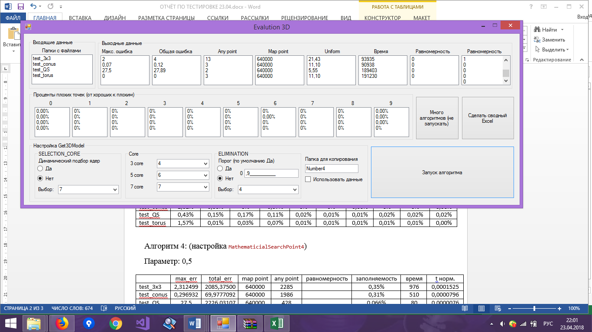

|  |  |  |  |  |  |  |  |  |  |
| --- | --- | --- | --- | --- | --- | --- | --- | --- | --- |
|  | max_err | total_err | map point | any point | равномерность  % | заполняемость  % | t | t норм. | Uniform  % |
| test_3x3 | 2 | 4 | 640000 | 13 | 0 | 0 | 93935 | 0,0146 | 21,43 |
| test_conus | 0,07 | 0,12 | 640000 | 3 | 0 | 0 | 90938 | 0,0142 | 11,10 |
| test_QS | 27,5 | 27,89 | 640000 | 2 | 0 | 0 | 189403 | 0,0135 | 5,55 |
| test_torus | 0 | 0 | 640000 | 3 | 0 | 0 | 191230 | 0,0136 | 11,10 |
| ∑ | 7,3925 | 8,0025 |  | 4,5 |  | 0 |  | 0,0140 |  |

Процент плохих точек по областям по отношению ко всем точкам (от «хороших» к «плохим»)

|  |  |  |  |  |  |  |  |  |  |  |
| --- | --- | --- | --- | --- | --- | --- | --- | --- | --- | --- |
|  | 1 | 2 | 3 | 4 | 5 | 6 | 7 | 8 | 9 | 10 |
| test_3x3 | 0,00% | 0% | 0% | 0% | 0% | 0% | 0% | 0% | 0% | 0,00% |
| test_conus | 0,00% | 0% | 0% | 0% | 0% | 0% | 0,00% | 0% | 0% | 0,00% |
| test_QS | 0,00% | 0% | 0% | 0% | 0% | 0% | 0% | 0% | 0% | 0,00% |
| test_torus | 0,00% | 0% | 0% | 0% | 0% | 0% | 0% | 0% | 0% | 0% |

№5 (хороший результат)

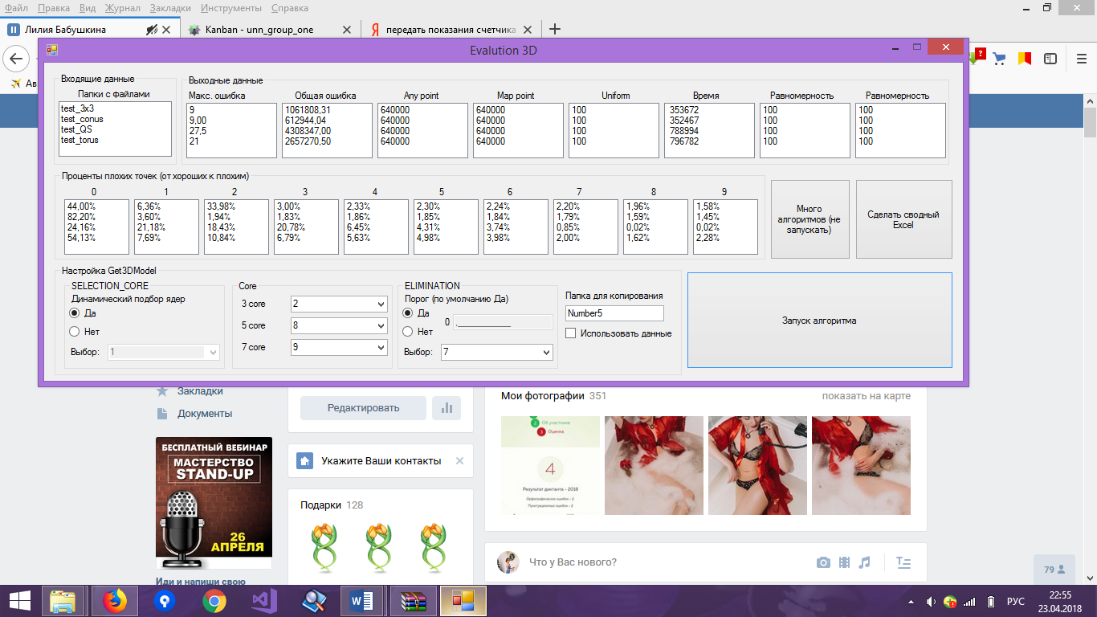

|  |  |  |  |  |  |  |  |  |  |
| --- | --- | --- | --- | --- | --- | --- | --- | --- | --- |
|  | max_err | total_err | map point | any point | равномерность  % | заполняемость  % | t | t норм. | Uniform  % |
| test_3x3 | 9 | 1061808,31 | 640000 | 640000 | 100 | 100 | 353672 | 0,055 | 100 |
| test_conus | 9,00 | 612944,04 | 640000 | 640000 | 100 | 100 | 352467 | 0,055 | 100 |
| test_QS | 27,5 | 4308347,00 | 640000 | 640000 | 100 | 100 | 788994 | 0,056 | 100 |
| test_torus | 21 | 2657270,50 | 640000 | 640000 | 100 | 100 | 796782 | 0,057 | 100 |
| ∑ | 16,625 | 2160092,4 |  |  |  | 100 |  | 0,056 | 100 |

Процент плохих точек по областям по отношению ко всем точкам (от «хороших» к «плохим»)

|  |  |  |  |  |  |  |  |  |  |  |
| --- | --- | --- | --- | --- | --- | --- | --- | --- | --- | --- |
|  | 1 | 2 | 3 | 4 | 5 | 6 | 7 | 8 | 9 | 10 |
| test_3x3 | 44,00% | 6,36% | 33,98% | 3,00% | 2,33% | 2,30% | 2,24% | 2,20% | 1,96% | 1,58% |
| test_conus | 82,20% | 3,60% | 1,94% | 1,83% | 1,86% | 1,85% | 1,84% | 1,79% | 1,59% | 1,45% |
| test_QS | 24,16% | 21,18% | 18,43% | 20,78% | 6,45% | 4,31% | 3,74% | 0,85% | 0,02% | 0,02% |
| test_torus | 54,13% | 7,69% | 10,84% | 6,79% | 5,63% | 4,98% | 3,98% | 2,00% | 1,62% | 2,28% |